International Tectonic Map of the Arctic at 1:5M scale – TeMAr-5000

TeMAr is one of several geological maps compiled in CGMW project “Atlas of Geological Maps of Circumpolar Arctic at 1:5 М scale” (to 60º N).

The international project was launched in 2003. It was initiated by geological surveys of Circum-Arctic states with active support from the UNESCO Commission for the Geological Map of the World (CGMW).

International working groups have accomplished in 2009 the compilation of Geological map (led by Geological Survey of Canada), Magnetic and Gravity Anomaly maps at 1:5 М scale (led by Geological Survey of Norway). In August 2008, these maps were displayed at the 33rd Session of the International Geological Congress in Oslo and subsequently printed in Canada (geological map) and Norway (magnetic and gravity maps).

Magnetic Anomaly Map | Gravity Anomaly Map | Geological Map
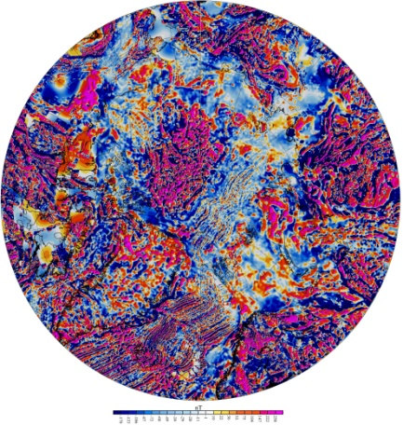 | 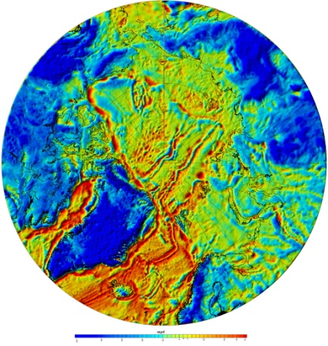 | 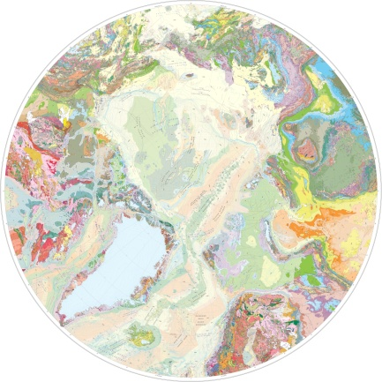
http://www.ngu.no/en-gb/hm/Publications/Reports/2009/2009-010/ | http://www.ngu.no/en-gb/hm/Publications/Reports/2009/2009-010/ | http://apps1.gdr.nrcan.gc.ca/mirage/mirage_list_e.php?id=225705

In 2010, upon completion of these basic maps, it became possible to undertake the compilation of the Tectonic Map of the Arctic.

TeMAr Working Group consists of representatives from several geological surveys and academic institutions: Oleg Petrov – leader of the WG, CGMW Vice-President of the Northern Eurasia Subcommission Sergey Shokalsky – Secretary General of the Northern Eurasia Subcommission; Yury Leonov – CGMW President of the Subcommission for Tectonic maps; Igor Pospelov - Secretary General of the Tectonic maps Subcommission; Manuel Pubellier - CGMW Secretary General; Christopher Harrison, Marc St-Onge, Richard Ernst (GSC); Arthur Grantz, Thomas Moore (USGS); Arne Solli, Carmen Gaina (NGU); Jan Faleide (University of Oslo); Harald Brekke (NPD); Michael Stephens (SGU); Pierpaolo Guarnieri (GEUS); Bernhard Cramer, Karsten Pierpjohn (BGR); Loic Labrousse (University РМС), Garrik Grikurov, Victor Poselov (VNIIOkeangeologia); Sergey Sokolov, Valery Vernihovsky, Victor Puchkov (Russian Academy of Sciences); Mark Verba (SevMorgeo); Nikolay Malyshev (RosNeft); Sergey Kashubin (VSEGEI); Sergey Drachev (ExxonMobil).

The tectonic map compilation is based on the following principles, which were used while developing the map legend:
– the map should enable the correlation of geological structures of deep-water parts of the Arctic Basin, shelves of the marginal seas and the surrounding mainland;
- in oceanic domains, areas with oceanic crust and spreading structures are distinguished in accordance with their age;
- in the areas with continental crust, two groups of geological complexes-indicators are mapped relating to the main types of tectonic processes. The first group comprises complexes generated by continental crust-forming accretion processes. The second group includes rock assemblages formed by tectonic and magmatic reworking of earlier consolidated continental crust: rifting and intraplate magmatism leading to the formation of large igneous provinces (LIPs) and basic dyke swarms manifesting continental break-up events;
- since the extraordinary size and structural complexity of the Arctic sedimentary basins, special attention is given to their full characterization in terms of spatial and age relations.

In April 2011, TeMAr working group examined and adopted the legend for the tectonic map at CGMW headquarters.

TeMAr will be compiled as a GIS project = 1:5 М hard copy+ArcGIS project+database.

Preliminary TeMAr layout includes the legend, several small-scale geophysical insets, Transpolar geotransect.

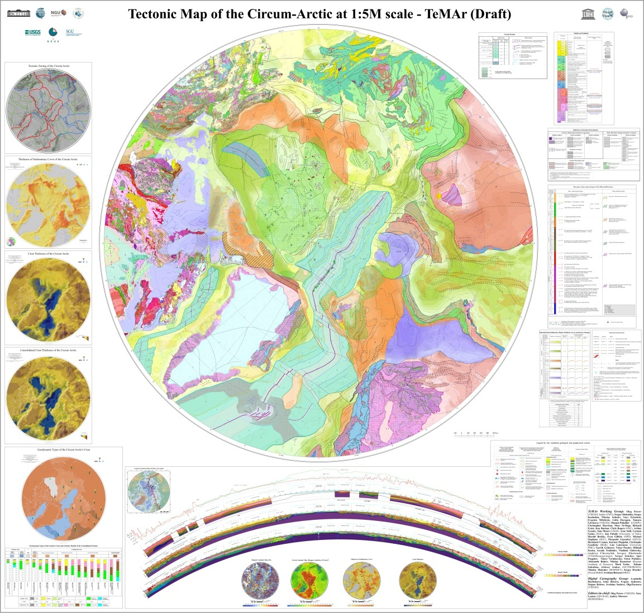

Tectonic Map of the Arctic (Draft) | 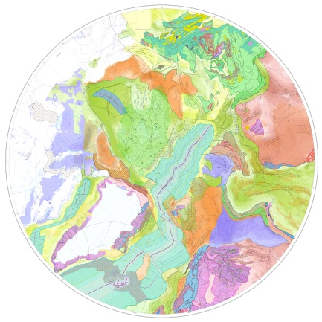 | Download Tectonic Map of the Arctic Draft.pdf

TeMAr-5000 legend | Download TeMAr legend

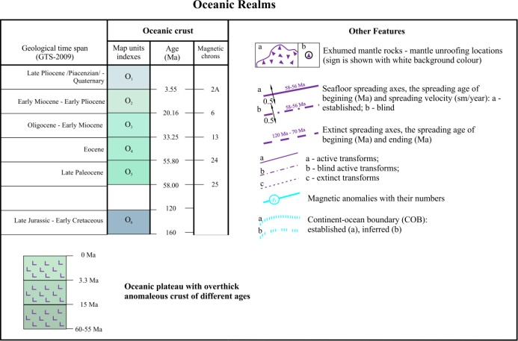 | In oceanic domains, areas with spreading oceanic crust are distinguished in accordance with their age (gray-blue spectrum); overthick crust of intraplate oceanic plateaus is indicated by a particular shade of gray-blue color. Designations for a continent-ocean boundary, identified linear magnetic anomalies, spreading axes with indication of spreading rate, transform faults and fracture zones, mantle unroofing localities on the Gakkel Ridge are also provided.  The sedimentary cover overlying the oceanic floor has no coloring and is only characterized by thickness isopachs.
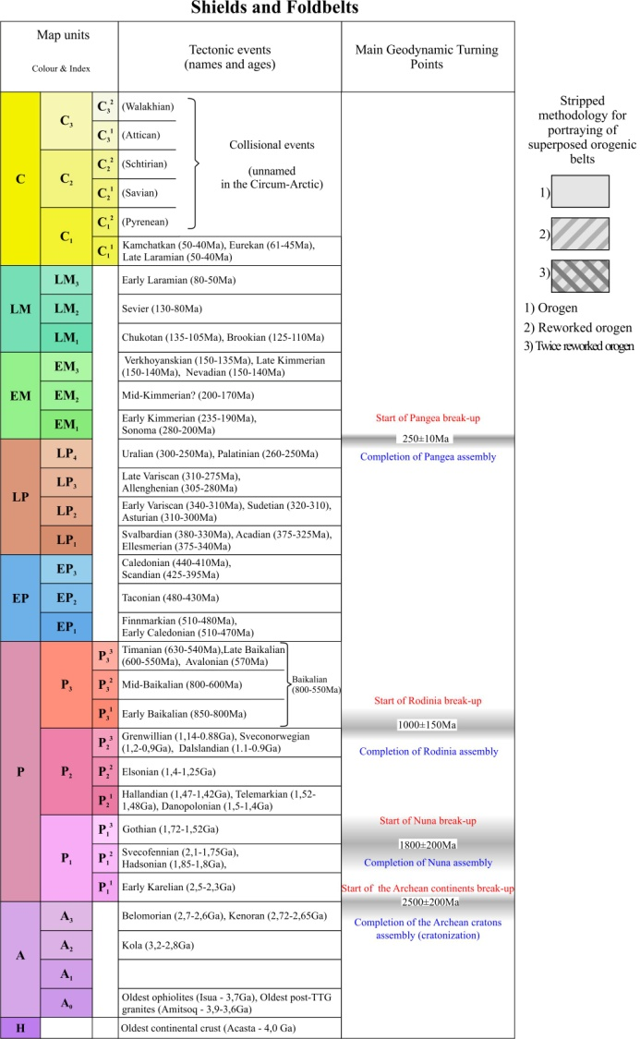 | The structure and evolution of continental realms are shown by colors corresponding to the age of tectonic units marking orogeny and/or cratonization as the main crust-forming events. Age of orogeny reflects the time of deformation, metamorphism, subduction/collision-related activities eventually leading to crust consolidation. In these areas, geological complexes-indicators of the main tectonic processes are shown. They include accretion, collision versus rifting and intraplate magmatism, while the Early Precambrian metamorphic structutres are shown separetely. The legend provides opportunity to show the areas reworked by younger tectonic processes.
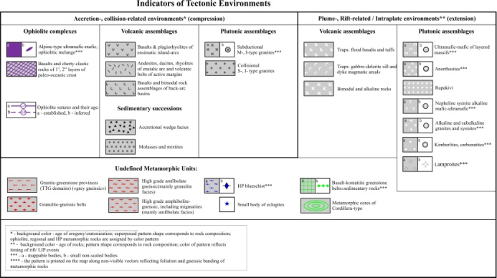 | Tectonic-dependent features:  - ophiolites and ophiolite sutures;  - arc-related and collision-related volcanic and plutonic complexes; syn-orogenic strata (molasse and olistostrome);  - plume- and rift-related) magmatic associations including LIPs and giant dike swarms  - metamorphic complexes subdivided into granulite, amphibolite, greenschist facies, and blueschist/eclogite/UHP assemblages
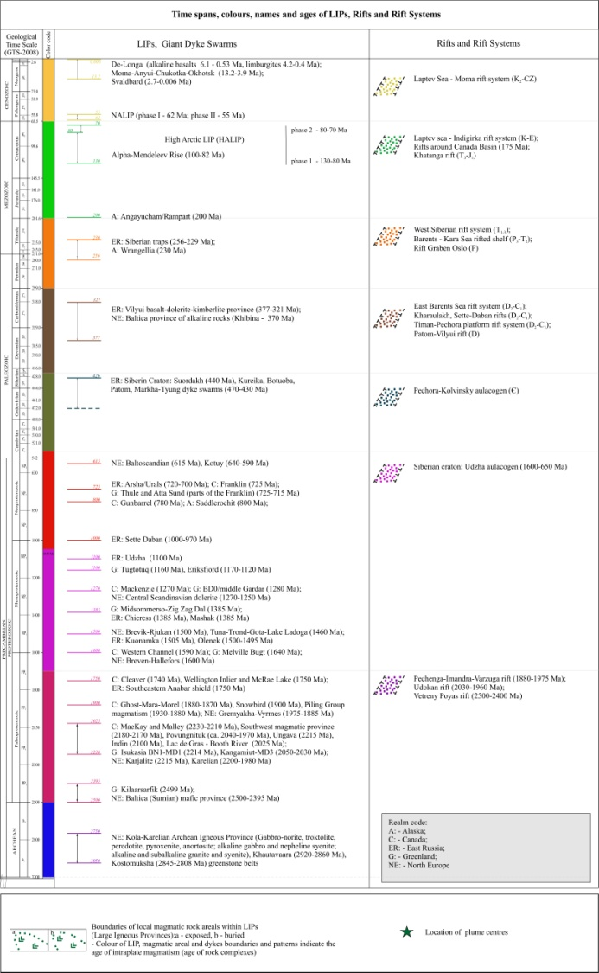 | LIP-related magmatic complexes and rifts.  The legend enables portraying large igneous provinces by means of color vectors (LIP outlines and dikes), polygons (major layered intrusions) and patterns (flood basalts).  Rifts will be shown by black boundaries and color patterns.  Color corresponds to the age of magmatism and/or rift fill.  Only NALIP, HALIP and Siberian LIP will appear on the map asoulined polygons occupied by flood basalts.  Precambrian LIPs are shown only by distribution of dike suite swarms (vectors) and layered intrusions (polygons) colored in accordance with the age of their formation.  On cratons these magmatic bodies are the only manifestations of LIPs of different age which usually overlap within more or less the same boundaries. For that reason they cannot be confidently designated on the 1:5 M map.
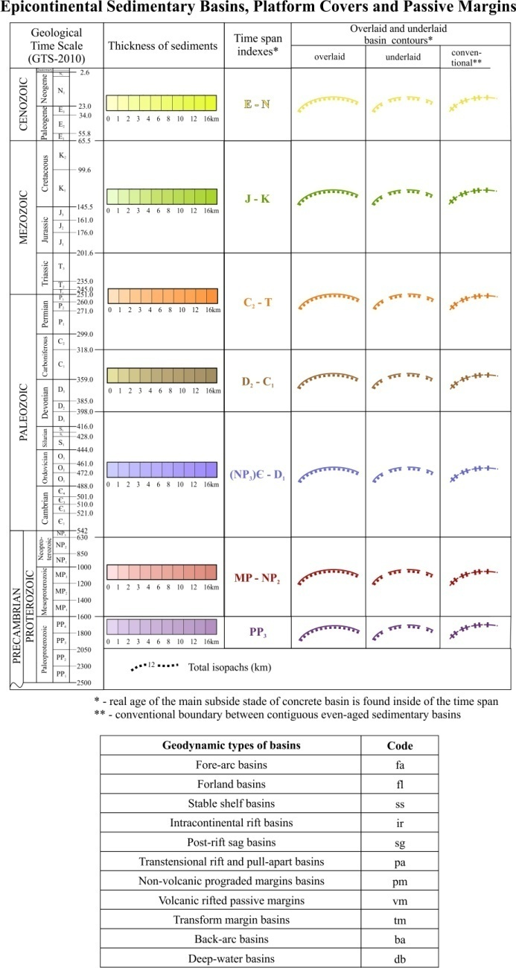 | Onshore and epicontinental offshore sediments greater than 1 km thick will be regarded as sedimentary basins.  The thicknesses of sedimentary successions will be color-coded according to the principal subsidence event.  The underlying and/or overlapping basins can be shown using the broken (“blind”) and continuous lines - boundaries.  The total thickness of sediments is expressed by a single isopach row. In case of superposed basins, thickness of sediments of each basin is shown by isopachs of its own color. The geodynamic diversity of basins is better to be portrayed by colours and symbols on a separate smaller-scale inset.
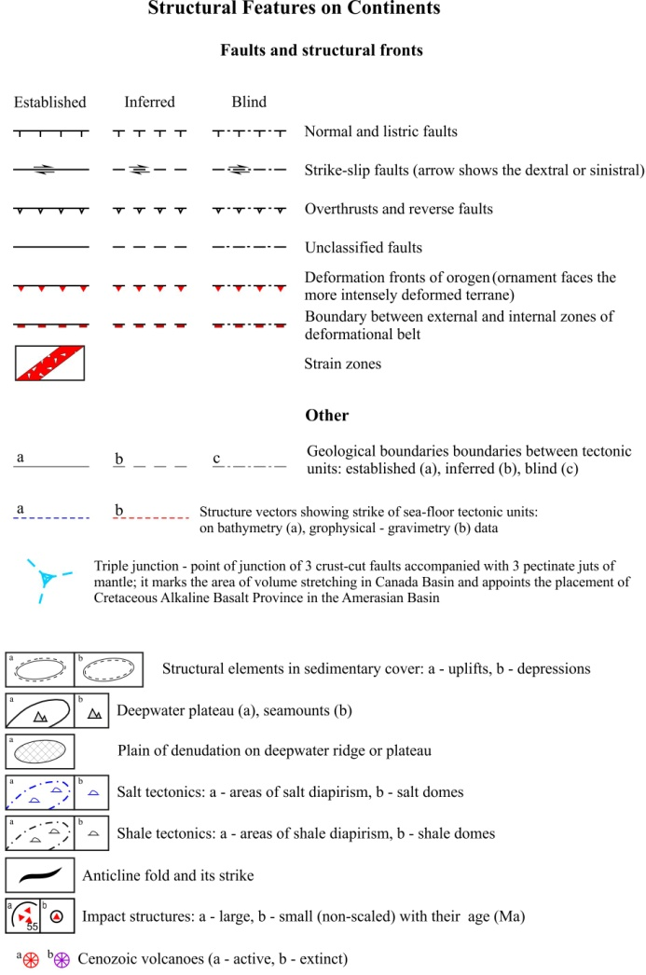 | Structural elements: faults of variable kinematic types, deformational fronts of orogens, boundaries between external and internal zones of foldbelts, salt and shale diapirs, thin-skinned tectonic deformations in sedimentary covers; melange and shear zones, volcanoes and impact structures. Established and inferred (including buried) faults are also distinguished.

The main Tectonic map has several maps-insets,
facilitated the understanding the Arctic deep structure

Inset 1 represents a geophysical domain map, which shows the general tectonic zoning of the Circumpolar Arctic. It was compiled from potential field geophysical data, a list of tectonic units can be download. | 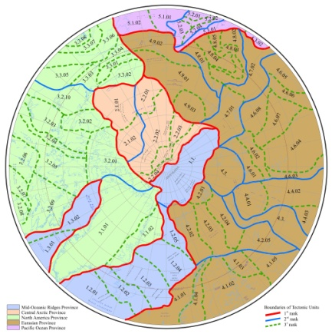 | Download Inset_1
Inset 2 demonstrates a sediment thickness map. It shows total thickness of undeformed sequences resting on the tectonic basement. The compilation is mainly based on the most recent seismic reflection data and deep seismic sounding results | 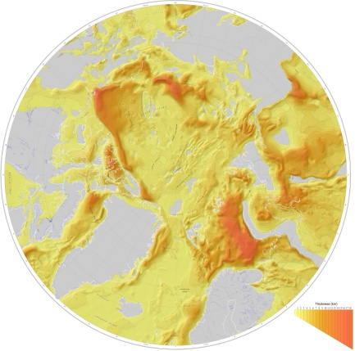 | Download Inset_2
Insets 3 and 4 are maps of Earth crust thickness (crust thickness up to mantle) and thickness of consolidated crust (crust thickness from low surface of sedimentary cover to upper mantle boundary). Time of the crust consolidation is determined by the age of complexes-indicators (S-granites, molasses, etc.) in combination with the final folding and drastic change of lithological formations. For their compilation, state-of-the-art reprocessing of all deep seismic sounding data available in the Circum-Arctic region (more than 100 profiles) was undertaken jointly by VSEGEI, VNIIOkeangeologia and SevMorgeo. | 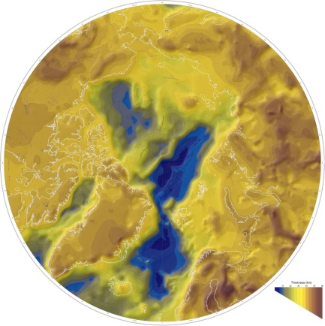 | Download Inset_3
 | 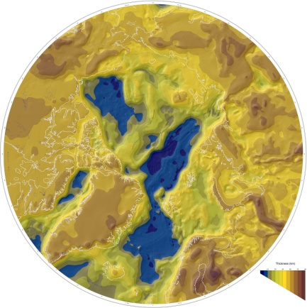 | Download Inset_4
Inset 5 is a sketch map of crustal types in the Arctic. It is accompanied by velocity models | 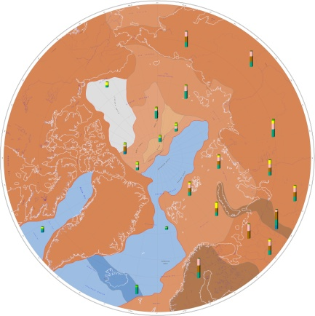 | Download Inset_5
 | 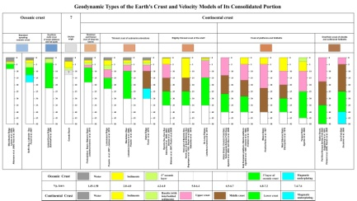 | Download Inset_5

